 | SEMINAR REPORT | 
A seminar Report on
Phishing Website Detection Techniques

Submitted in partial fulfilment for the award of
THIRD YEAR DIPLOMA IN
COMPUTER ENGINEERING
By
Sr.  No | Enrollment  Number | Seat Number | Name of student
1 | 24610960226 | 388534 | Pagar Ishan Ashok
2 | 24610960227 | 388535 | Pagare Mehul Sandip
3 | 24610960203 | 388516 | Jathar Sarang Arvind
4 | 24610960220 | 388528 | Patil Manish Chandrakant

FOR THE ACADEMIC YEAR : 2026 – 2027

DEPARTMENT OF COMPUTER ENGINEERING
S.S.V.P.S's Bapusaheb Shivajirao Deore Polytechnic, Dhule
(Institute Code : 0059)

S.S.V.P.S's Bapusaheb Shivajirao Deore Polytechnic, Dhule
(An Affiliated Institute of Maharashtra State Board of Technical Education)
DEPARTMET OF COMPUTER ENGINEERING
CERTIFICATE
Sr.  No | Enrollment  Number | Seat Number | Name of student
1 | 24610960226 | 388534 | Pagar Ishan Ashok
2 | 24610960227 | 388535 | Pagare Mehul Sandip
3 | 24610960203 | 388516 | Jathar Sarang Arvind
4 | 24610960220 | 388528 | Patil Manish Chandrakant

of CO5K Semester of Diploma in Computer Engineering of S.S.V.P.S’s B. S. Deore Polytechnic, Dhule (Inst.Code: 059) has completed the term work satisfactorily in Course Seminar Presentation and Project Initiation (Course Code: 315003) for the academic year 2026 to 2027 as prescribed in the curriculum.

Place : Dhule
Date : .....................

Signature: Signature:
Name : Shraddha S Hajari Name : Nishad D Patel

Subject Teacher Head of the Department



TABLE OF CONTENT
Sr. No. | Chapter | Page No.
 | Abstract | I
 | List of Figures | Ii
 | List of Tables | Iii
1 | Introduction | 1
2 | Literature Review | 2
3 | Information/Chapters | 7
4 | Advantages and Disadvantages | 15
5 | Conclusion | 16
6 | Project Initiation : | 17
6 | 6.1) Description of problem statement. | 17
6 | 6.2) Scope and objectives. | 18
6 | 6.3) Stake holder | 18
6 | 6.4) Platform/ Equipment/ Resources identification. | 19
7 | Seminar Presentation
 | Bibliography
 | References

ABSTRACT
Phishing is a type of cyberattack in which attackers create fake websites that look similar to genuine websites to steal sensitive information such as usernames, passwords, banking details, and personal data. These attacks commonly target online banking, social media, e-commerce, and email users. As internet usage increases, phishing attacks have become a serious cybersecurity concern.
Phishing Website Detection Techniques are methods used to identify and prevent users from accessing fraudulent websites. Various techniques are used for phishing detection, including blacklist-based detection, whitelist-based detection, URL-based analysis, heuristic-based detection, machine learning, and deep learning. Traditional methods use known malicious URLs and predefined rules, while intelligent techniques analyze website features and patterns to identify suspicious websites.
This seminar studies different phishing website detection techniques, their working principles, advantages, limitations, and future scope. It also explains how machine learning and deep learning can improve the accuracy and efficiency of phishing detection. The main objective is to understand how phishing websites can be identified and how users can be protected from online fraud.
Keywords: Phishing, Cybersecurity, Website Detection, Machine Learning, Deep Learning, URL Analysis, Online Security.

LIST OF FIGURES

Fig. No. | Title | Page No.
3.6 | Overview of Phishing Website Detection | 13
3.7 | Working of a Phishing Attack | 14

LIST OF TABLES

Table No. | Title | Page No.
2.1 | Literature Review | 5
3.3 | Technology Purpose | 10
3.4 | Features Use for Detection | 12
6.5 | Platform | 19
6.6 | Equipment | 19
6.7 | Resources | 20

CHAPTER 1
INTRODUCTION
The internet has become an essential part of modern life. People use websites for online banking, shopping, education, communication, entertainment, and many other activities. However, the increasing use of online services has also increased the risk of cyberattacks.
One of the most common cyber threats is phishing. In a phishing attack, an attacker creates a fake website that appears to be a legitimate website. The attacker may send a fraudulent email, message, or social media link to convince users to visit the fake website and enter confidential information.
For example, a phishing website may look similar to a genuine banking login page. When users enter their login credentials, the information may be captured by the attacker.
Phishing Website Detection Techniques help identify these malicious websites before users disclose their sensitive information. Detection methods can analyse website URLs, domain information, HTML content, website behaviour, and other characteristics.
Traditional detection techniques rely on blacklists and predefined rules. Modern approaches use machine learning and deep learning to recognize suspicious patterns and detect previously unknown phishing websites.
Therefore, studying phishing website detection is important for improving cybersecurity, protecting user information, and reducing online fraud.

CHAPTER 2
LITERATURE REVIEW
The literature review examines existing research on phishing website detection and identifies the techniques, technologies, strengths, and limitations discussed by researchers.
2.1 A Systematic Literature Review on Phishing Website Detection Techniques
This research area reviews existing phishing detection methods, including blacklists, heuristic approaches, machine learning, and deep learning. Systematic reviews help researchers understand the development of phishing detection and compare the effectiveness of different approaches.
Main contribution: Provides an overview of existing detection methods and their limitations.
Future scope: Developing more accurate, adaptive, and real-time detection systems.
2.2 Blacklist-Based Phishing Detection
Blacklist-based detection compares a website URL with a database of known malicious websites. If a URL matches a listed phishing website, the system can warn the user or block access.
Main contribution: Simple and effective for detecting previously reported phishing websites.
Limitation: Newly created phishing websites may not appear in the blacklist.

2.3 Heuristic-Based Detection
Heuristic detection uses predefined rules to identify suspicious website characteristics. These may include unusual URLs, excessive subdomains, misleading domain names, and suspicious webpage elements.
Main contribution: Can detect suspicious websites without requiring an exact blacklist match.
Limitation: Attackers can modify website characteristics to avoid predefined rules.
2.4 Machine Learning-Based Detection
Machine learning techniques use features extracted from URLs, domains, and webpages to classify websites as legitimate or phishing. Common algorithms include Decision Trees, Random Forest, Support Vector Machines (SVM), Logistic Regression, and Naive Bayes.
Main contribution: Learns patterns from labelled data and can identify phishing websites that are not already listed in a blacklist.
Limitation: Performance depends on training data quality, feature selection, and changes in attack patterns.
2.5 Deep Learning-Based Detection
Deep learning uses neural networks to identify complex patterns in website data. Techniques such as Convolutional Neural Networks (CNNs), Recurrent Neural Networks (RNNs), and other neural architectures may be used for URL, text, or webpage analysis.
Main contribution: Can learn complex patterns and reduce the need for manually designed features in some systems.
Limitation: Often requires more computational resources and substantial training data.

2.6 Research Gap
Existing phishing detection methods face several challenges. Blacklists may fail to identify new attacks, while rule-based systems may be bypassed by changing website characteristics. Machine learning models may lose accuracy when phishing techniques change, and deep learning systems may require more computing power.
Therefore, there is a need for detection systems that are accurate, fast, adaptive, and capable of identifying previously unseen phishing websites while minimizing false warnings.

Table No 2.1: Literature review:
Sr. No. | Research Paper / Year | Approach Type | Technologies Used | Datasets | Key Objective | Limitations
1 | A Systematic Literature Review on Phishing Website Detection Techniques (2023) | Systematic Literature Review | Blacklists, Visual Similarity, ML, DL | 80 research papers; PhishTank and Alexa discussed | To review and compare phishing detection techniques | Results vary across datasets and studies
2 | A Survey of Machine Learning-Based Solutions for Phishing Website Detection (2021) | ML-Based Survey | Feature Extraction, ML Classifiers | Multiple datasets from reviewed studies | To study ML methods for phishing detection | Dataset quality and changing attacks affect performance
3 | Phishing or Not Phishing? A Survey on the Detection of Phishing Websites (2023) | Survey-Based | List-Based, Similarity-Based, ML | Datasets from reviewed studies | To compare detection methods and identify research gaps | New phishing websites are challenging to detect
4 | Web Phishing Detection Techniques: A Survey on the State-of-the-Art, Taxonomy | Survey and Taxonomy | URL Analysis, Heuristics, Visual Similarity, ML | Not specified in summary | To classify detection techniques and identify future directions | Performance varies across datasets
Sr. No. | Research Paper / Year | Approach Type | Technologies Used | Datasets | Key Objective | Limitations
5 | Machine Learning Approach for Phishing Website Detection: A Literature Survey | ML-Based Survey | ML Algorithms, Feature Extraction | Not specified in summary | To review ML approaches for phishing detection | No single algorithm performs best in every situation
6 | Across the Spectrum: In-Depth Review of AI-Based Models for Phishing Detection (2024) | AI-Based Survey | Machine Learning, Deep Learning | Research from 2020–2024 | To compare AI models and identify research gaps | Different datasets make comparisons difficult
7 | A High-Accuracy Phishing Website Detection Method Based on Machine Learning (2023) | Supervised ML | Logistic Regression, KNN, Naive Bayes, Random Forest, SVM, XGBoost | 58,000 legitimate and 30,647 phishing websites; 112 attributes | To compare six ML algorithms | Results depend on data quality and testing methods
8 | Detection of Malicious URLs Using Machine Learning (2024) | URL-Based ML | URL Feature Extraction, ML Classifier | Not specified in summary | To detect malicious URLs automatically | URL patterns change and data needs updating
Sr. No. | Research Paper / Year | Approach Type | Technologies Used | Datasets | Key Objective | Limitations
9 | Machine Learning Techniques for Detecting Phishing URL Attack | Feature-Based ML | Neural Networks, Naive Bayes, AdaBoost | Over 11,000 websites from Kaggle; 30 features | To compare ML algorithms for phishing URL detection | Accuracy alone is insufficient
10 | Phishing Website Detection Using Machine Learning: A Review (2024) | ML-Based Review | ML Classifiers, Feature Selection | Not specified in summary | To understand ML-based phishing website classification | Models may struggle when attack patterns change
11 | A Survey and Classification of Web Phishing Detection Schemes | Survey and Classification | Blacklists, Heuristics, Similarity-Based Methods, ML | Not specified in summary | To classify and compare detection schemes | Trade-offs in speed, accuracy and maintenance
12 | Phishing Website Detection: General Methods and Research Directions | General Synthesis | URL Analysis, Domain Analysis, ML, DL | No independent dataset | To summarize common findings and future research | Not an independent published research paper

CHAPTER 3
INFORMATION
3.1 Chapter One: Fundamentals of Phishing
Phishing is a social engineering technique used to deceive people into revealing confidential information. Attackers often exploit trust in familiar brands, organizations, and online services.
A typical phishing attack follows these stages:
- The attacker creates a fraudulent website.
- The attacker shares the website link through email, SMS, advertisements, or social media.
- The victim opens the link and believes the website is genuine.
- The victim may enter sensitive information.
- The attacker may misuse the captured information.
Phishing website detection attempts to identify the fraudulent website before the user is harmed.
3.2 Chapter Two: Phishing Website Detection Techniques
This technique checks the requested URL against a database of known malicious URLs. If a match is found, the website is flagged as suspicious.
2. Whitelist-Based Detection
A whitelist contains websites that are considered trusted. A website not included in the whitelist may be treated as unverified or require further checking. Being absent from a whitelist does not automatically mean that a website is malicious.

3. URL-Based Detection
URL-based detection examines the address of a website for suspicious characteristics, such as:
- Unusually long URLs.
- Misleading use of a trusted brand name.
- Excessive subdomains.
- Unusual characters or URL structures.
- IP addresses used instead of conventional domain names.
- Suspicious combinations of words in the domain.
4. Content-Based Detection
Content-based detection examines webpage elements, including HTML code, forms, links, page text, and other characteristics. It attempts to identify similarities to legitimate websites or patterns associated with phishing.
5. Heuristic-Based Detection
This approach uses security rules to identify suspicious properties. It is useful when a website has not yet been reported to a blacklist.
6. Machine Learning-Based Detection
Machine learning models learn from labelled examples of legitimate and phishing websites. The model analyzes extracted features and predicts the likely class of a new website.
7. Deep Learning-Based Detection
Deep learning models learn complex patterns from URLs, text, HTML, and other available data. They can be useful for identifying patterns that are difficult to express through fixed rules.
8. Hybrid Detection
Hybrid systems combine two or more techniques, such as blacklists, URL analysis, and machine learning. Combining complementary methods may improve detection coverage, although performance depends on system design and evaluation.
Tabel No 3.3: Technology | Purpose:
Sr. No. | Technology | Purpose
1 | Python | To develop phishing website detection algorithms.
2 | Visual Studio Code | To write, edit, and run Python programs.
3 | Pandas | To load, organize, and process website datasets.
4 | NumPy | To perform numerical calculations and data analysis.
5 | Scikit-learn | To implement and evaluate machine learning algorithms.
6 | TensorFlow / PyTorch | To develop deep learning models for phishing detection.
7 | HTML and CSS | To understand webpage structure and design a simple user interface.
8 | Flask | To connect the detection model with a web-based application.
9 | Phishing URL Datasets | To provide phishing and legitimate website examples for training and testing.
10 | Web Browser | To access websites and test the detection system.
11 | Microsoft Word / WPS Office | To prepare and format the seminar report.
12 | Microsoft PowerPoint / WPS Presentation | To prepare seminar presentation slides.3.4 Chapter Four: System Architecture

A general phishing website detection system can be divided into the following stages:
1. Website URL Input
User enters or submits a URL
2. Feature Extraction
URL, domain, and webpage characteristics
3. Detection Engine
Rules, blacklist checks, or trained ML model
4. Classification
Likely legitimate, suspicious, or phishing
5. Result and Warning
Display the result to the user
Working explanation:
- The user submits a website URL.
- The system extracts relevant characteristics from the URL or webpage.
- The detection engine evaluates the characteristics using its selected technique.
- The system classifies the URL based on the evidence and model output.
- A warning or classification result is shown to the user.
A classification result is not a guarantee of safety. Unknown websites should be treated cautiously, even if a detection system does not flag them.

Tabel No 3.4 : Features Used for Detection
Feature | Description
URL length | Measures the length of the website address
Domain age | Indicates how long the domain has existed, if reliable data is available
HTTPS status | Indicates whether the connection uses HTTPS
Subdomain count | Measures the number of subdomains
Special characters | Identifies unusual characters in the URL
IP address usage | Checks whether an IP address is used directly in the URL
Redirect behaviour | Examines how the browser is redirected
HTML characteristics | Analyzes webpage structure and elements
External links | Examines links pointing to other domains
Brand similarity | Checks for possible impersonation of trusted brands

No single feature can reliably determine whether every website is malicious. For example, HTTPS protects data in transit but does not prove that the website itself is trustworthy.

3.5 : Evaluation of Detection Systems
A phishing detection model should be tested using appropriate data that was not used to train it.
Common evaluation metrics include:
- Accuracy: The proportion of all predictions that are correct.
- Precision: The proportion of websites predicted as phishing that are actually phishing.
- Recall: The proportion of actual phishing websites that the system correctly detects.
- F1-score: A combined measure of precision and recall.
- False positive rate: The proportion of legitimate websites incorrectly flagged as phishing. Accuracy alone may be misleading if the dataset contains many more legitimate websites than phishing websites. A good evaluation should report several metrics and use a representative test dataset.
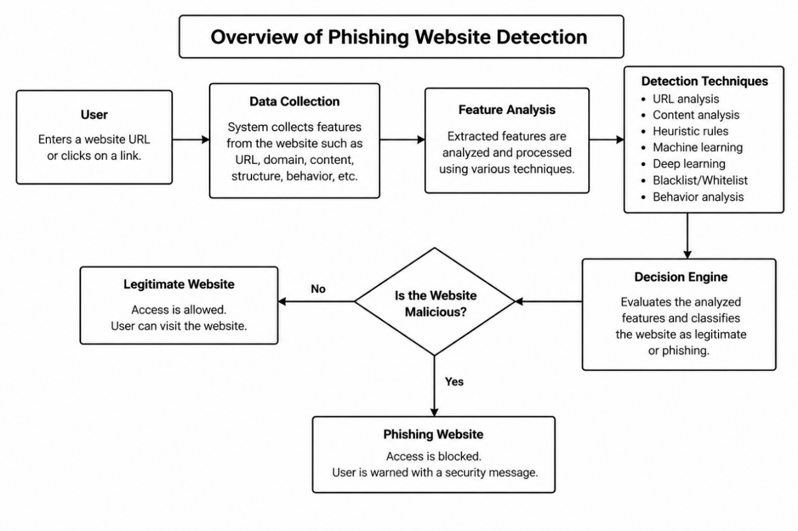
Fig No 3.6: overview of phishing website detection
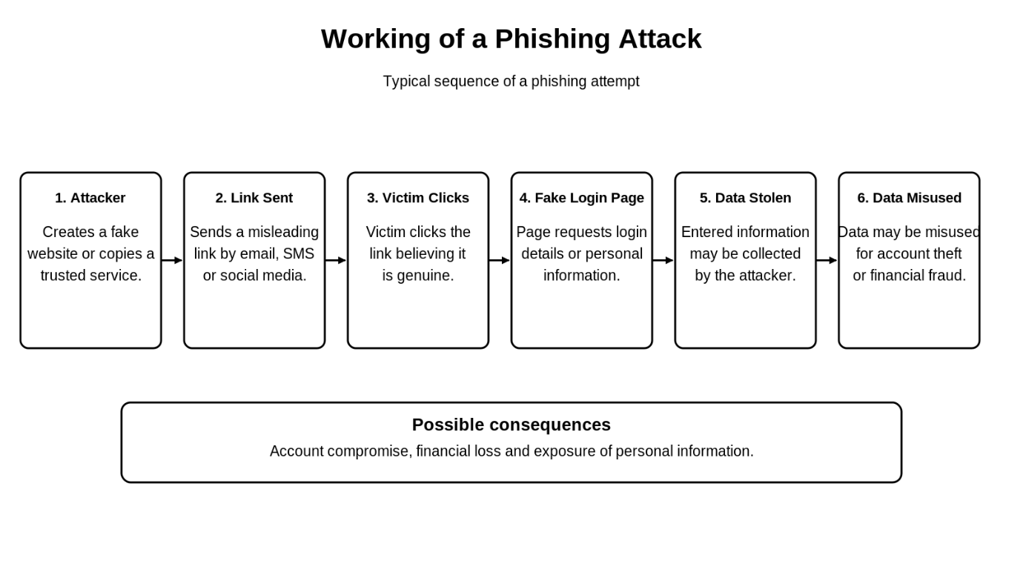
Fig 3.7: working of a phishing attack

CHAPTER 4
ADVANTAGES AND DISADVANTAGES
4.1 Advantages
- Improved security: Helps protect users from fraudulent websites.
- Early detection: Can identify suspicious websites before users submit confidential information.
- Reduced financial fraud: Helps reduce exposure to fraudulent banking and payment pages.
- Automated analysis: Machine learning can analyze many website features automatically.
- Detection of new threats: Some heuristic and learning-based systems can identify previously unseen phishing patterns.
- Scalability: Automated detection can process large numbers of URLs.
- Better user awareness: Warnings help users recognize potentially dangerous websites.
4.2 Disadvantages
- False positives: Legitimate websites may sometimes be incorrectly flagged.
- False negatives: Some phishing websites may escape detection.
- Dataset dependency: Machine learning performance depends on the quality and diversity of training data.
- Changing attack techniques: Attackers continually modify websites to evade detection.
- Computational requirements: Complex models may require additional processing power.
- Maintenance requirements: Blacklists, detection rules, and models need regular updates.
CHAPTER 5
CONCLUSION
Phishing website detection is an important part of cybersecurity because phishing attacks can lead to the theft of passwords, banking information, and other sensitive data. Different detection techniques have been developed to identify fraudulent websites and protect internet users.
Traditional methods, such as blacklists and whitelists, are useful in specific situations but have limitations when dealing with new or changing threats. URL-based and heuristic methods can identify suspicious characteristics, while machine learning and deep learning provide additional capabilities for analyzing complex patterns.
Hybrid detection systems can combine multiple methods to improve detection coverage. However, their effectiveness must be evaluated using reliable datasets and suitable metrics, including precision, recall, F1-score, and false positive rate.
In conclusion, no single technique can detect every phishing website. A combination of technical detection, regular updates, secure browsing practices, and user awareness offers a stronger approach to phishing prevention. Future research can focus on real-time detection, explainable artificial intelligence, privacy-preserving analysis, and better identification of previously unseen phishing attacks.

CHAPTER 6
PROJECT INITIATION
6.1 Description of Problem Statement:
Phishing websites are fraudulent websites designed to imitate legitimate websites and deceive users into revealing confidential information. These websites can cause financial losses, identity theft, account compromise, and privacy violations.
Traditional detection techniques often depend on previously identified malicious URLs or predefined rules. Therefore, newly created phishing websites may not be detected immediately. Attackers also change domain names, URLs, and webpage content to avoid detection.
The main problem is to identify phishing websites accurately and efficiently while reducing false positives and false negatives. The detection approach should analyze suitable website features and provide a clear classification or warning to the user.
Problem statement: To study and evaluate different phishing website detection techniques and understand how URL analysis, heuristic methods, machine learning, and deep learning can be used to identify phishing websites and improve online security.

6.2 Scope and Objectives

Scope:

The scope of this seminar includes:

Studying the fundamentals and types of phishing attacks.

Understanding traditional and modern phishing detection methods.

Examining URL-based, content-based, and domain-based features.

Studying machine learning and deep learning approaches.

Comparing the strengths and limitations of different techniques.

Understanding the metrics used to evaluate detection performance.

Exploring possible future improvements in phishing detection.

The seminar focuses on the detection and prevention of phishing websites. It does not require building a complete commercial security product.

Objectives

To understand phishing attacks and their impact on internet users.

To study different phishing website detection techniques.

To understand the role of machine learning and deep learning in cybersecurity.

To identify useful features for phishing website classification.

To compare detection methods based on their advantages and limitations.

To study evaluation metrics for measuring detection performance.

To explore future research directions for accurate and efficient phishing detection
6.3 Stakeholders:
Sr. No. Stakeholder Role and Responsibility
1. Internet Users: Use phishing detection systems to identify suspicious websites and protect personal information.
2. Students and Researchers: Study phishing detection techniques and conduct research to improve detection methods.
3. Cybersecurity Professionals: Develop, test, and maintain phishing detection systems.
4. Banks and Financial Institutions : Protect customers from fake banking websites and online financial fraud.
5. Website Owners: Protect their websites and users against phishing attacks and website impersonation.
6. Educational Institutions: Promote cybersecurity awareness and provide resources for learning.
7. Software Developers: Design and implement phishing detection applications and maintain their functionality.
8. Organizations: Implement security measures to reduce phishing risks

6.4 Platform/Equipment/Resources:
Tabel No 6.5: Platform:
Sr. No. | Platform | Purpose
1 | Windows Operating System | To run software and prepare the seminar project.
2 | Python | To implement phishing website detection algorithms.
3 | Visual Studio Code | To write and execute Python programs.
4 | Microsoft Word / WPS Office | To prepare and format the seminar report.
5 | Microsoft PowerPoint / WPS Presentation | To prepare seminar presentation slides.
6 | Google Scholar | To search for academic research papers.
7 | Google Chrome / Web Browser | To access websites and test the detection system

Tabel No 6.6: Equipment:
Sr. No. | Equipment | Purpose
1 | Laptop / Computer | To conduct research, write code, and prepare the report.
2 | Internet Connection | To access research papers, datasets, and technical documentation.
3 | Smartphone | To access online resources and review the presentation when required.
4 | Projector | To display seminar presentation slides to the audience.
5 | Pen Drive / External Storage | To store and transfer project files and presentation documents.
6 | Power Supply / Charger | To keep the laptop operational during project work and presentation.

Tabel No 6.7: Resources
Sr. No. | Resource | Purpose
1 | Research Papers | To study existing phishing website detection techniques.
2 | Phishing URL Dataset | To obtain examples of known phishing websites for analysis.
3 | Legitimate URL Dataset | To obtain examples of legitimate websites for comparison.
4 | Python Libraries | To process data and implement detection algorithms.
5 | Pandas and NumPy | To organize, process, and analyze website data.
6 | Scikit-learn | To train and evaluate machine learning models.
7 | TensorFlow / PyTorch | To develop deep learning models, if required.
8 | Technical Documentation | To understand algorithms, libraries, and detection methods.
9 | Internet Security References | To understand phishing attacks and website security practices.

CHAPTER 7
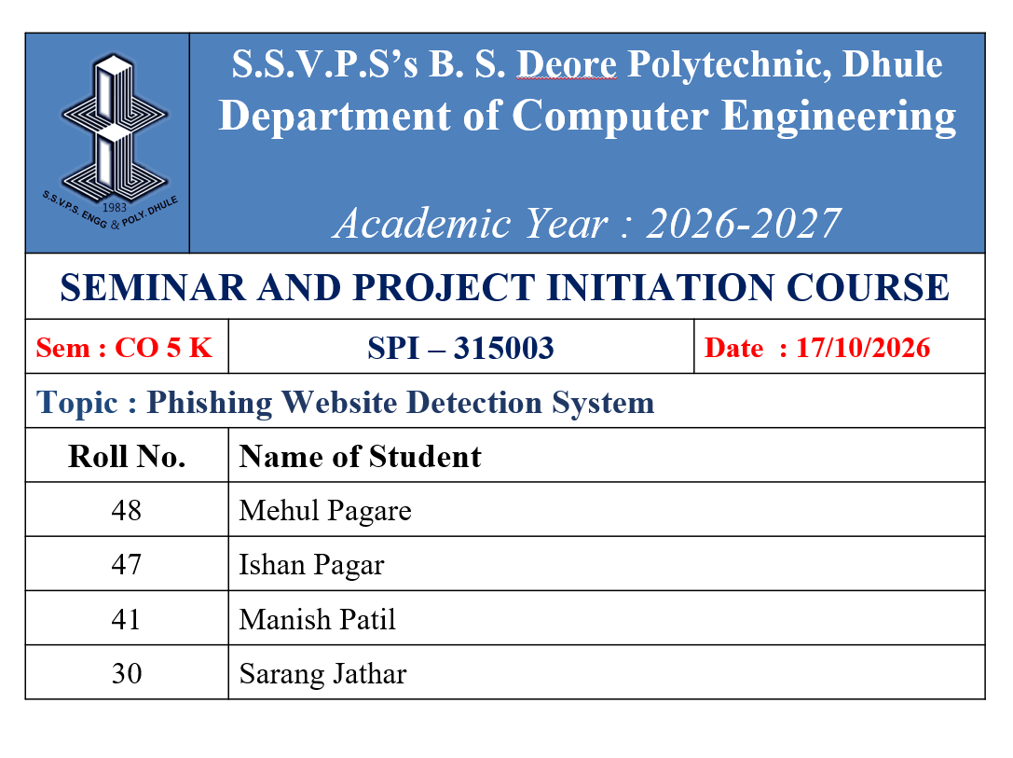
Seminar Presentation
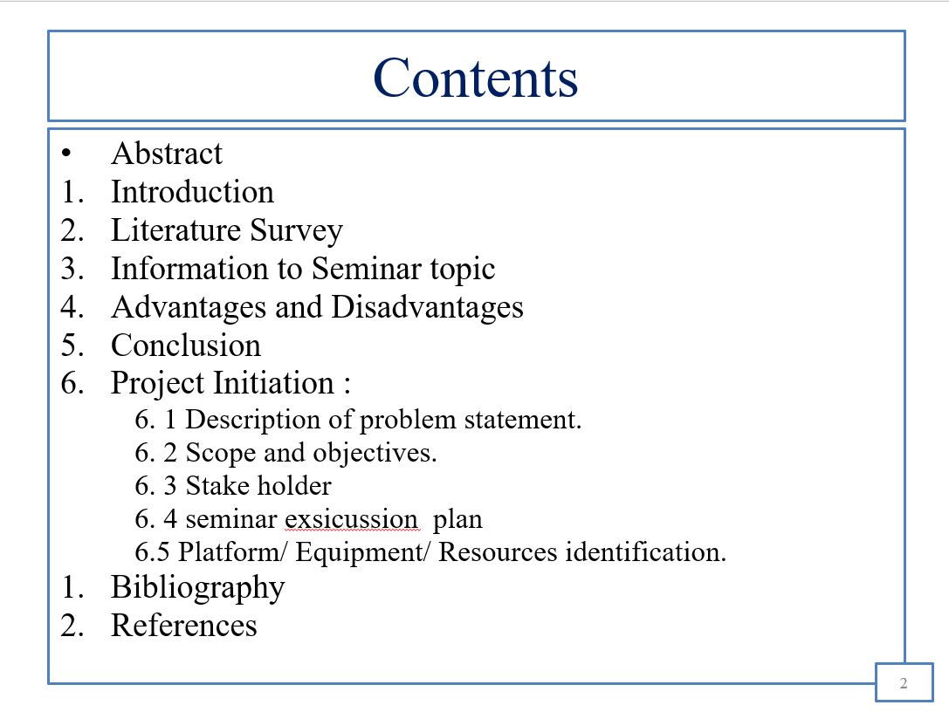

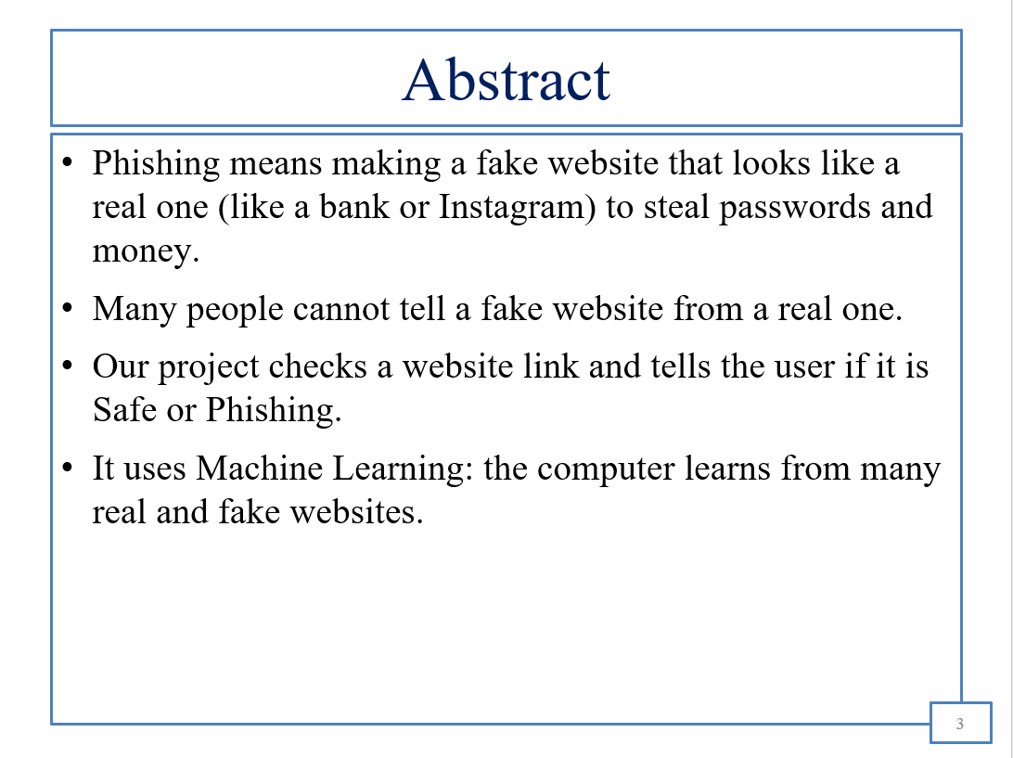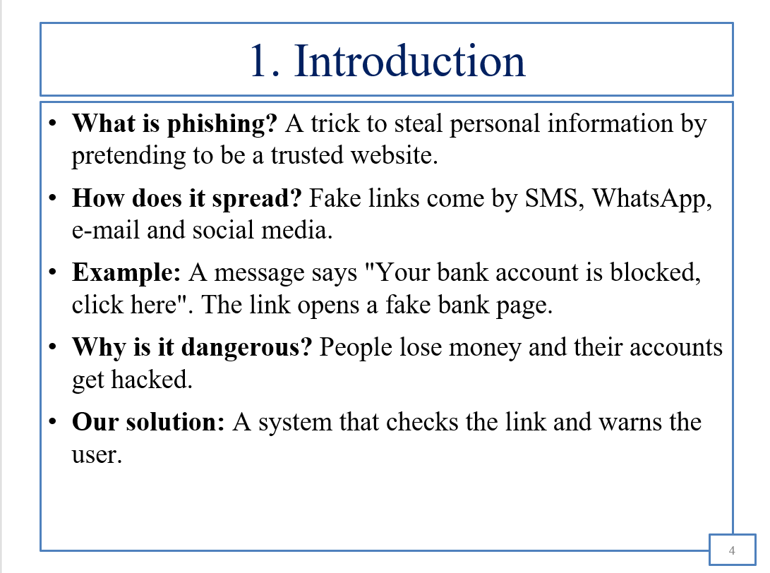
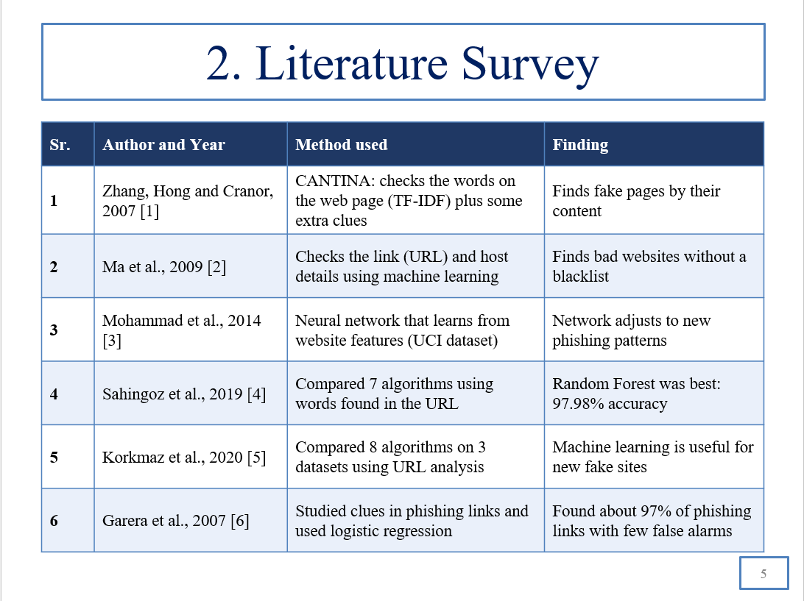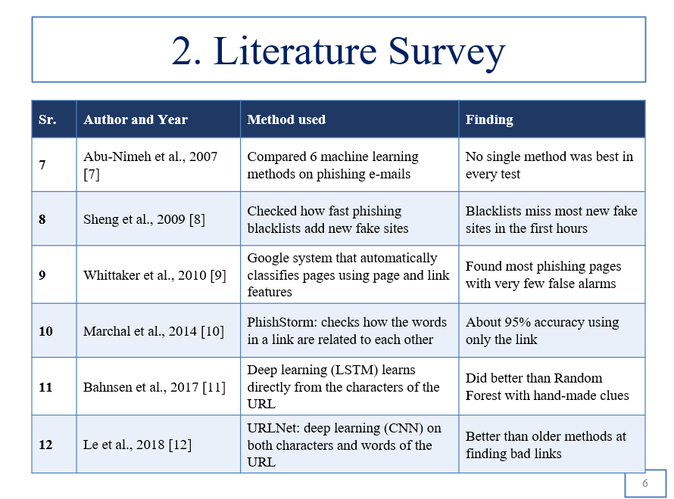
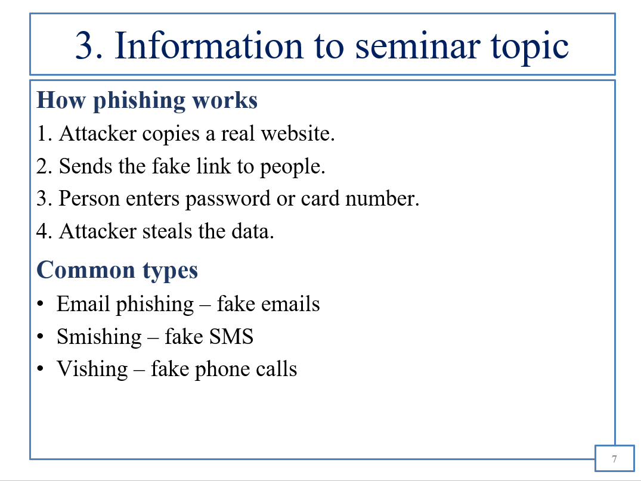
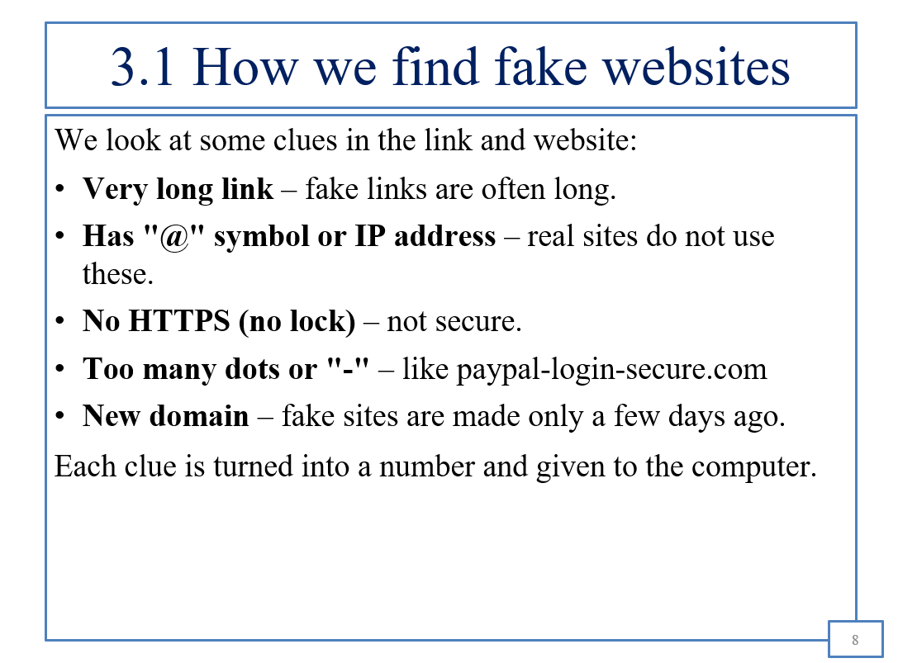
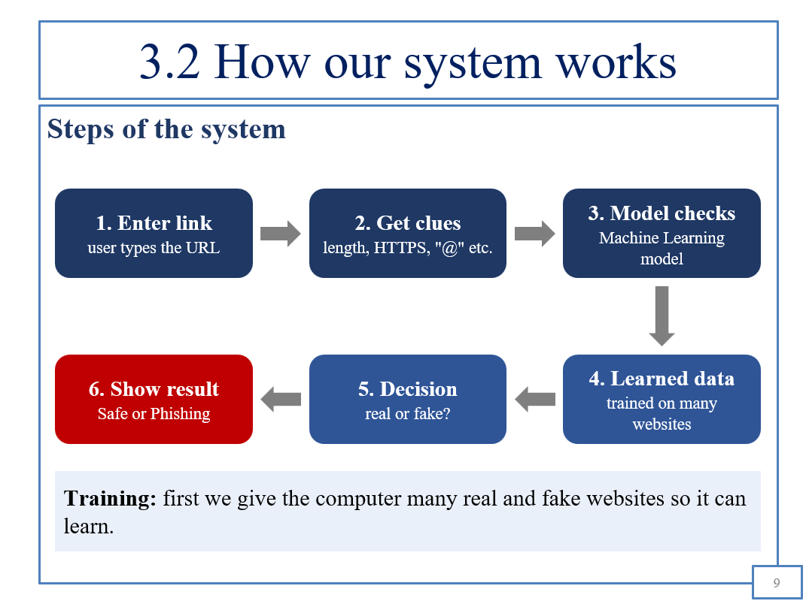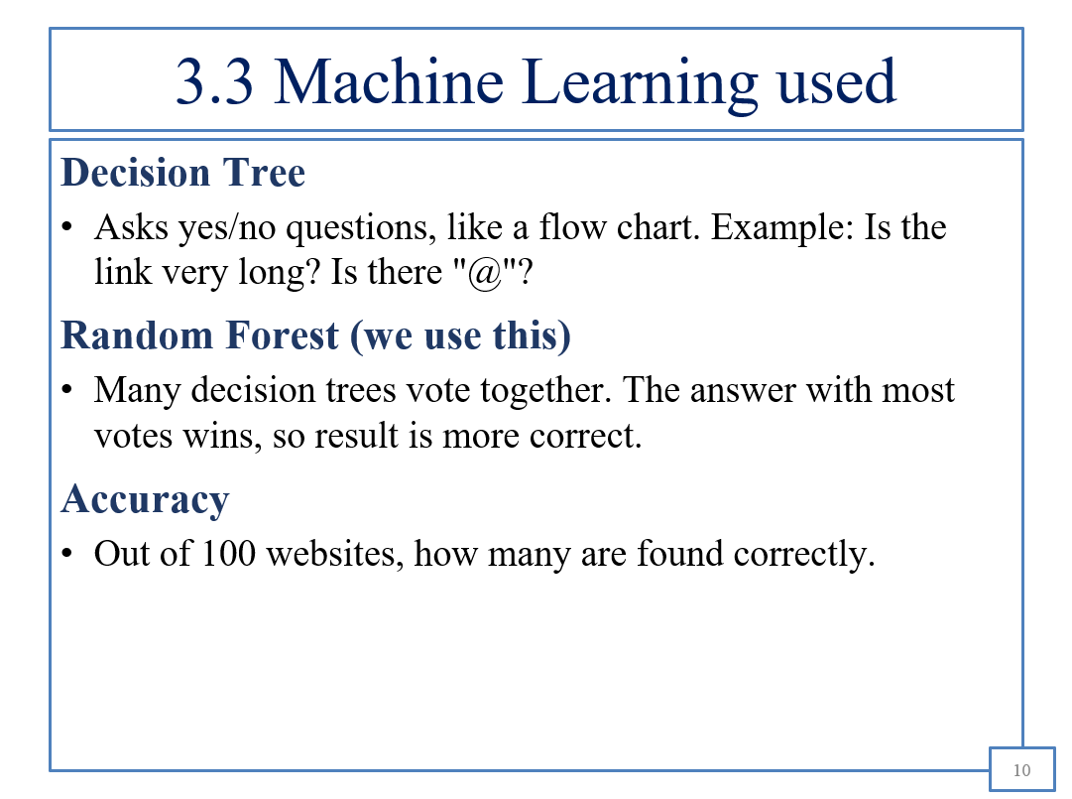
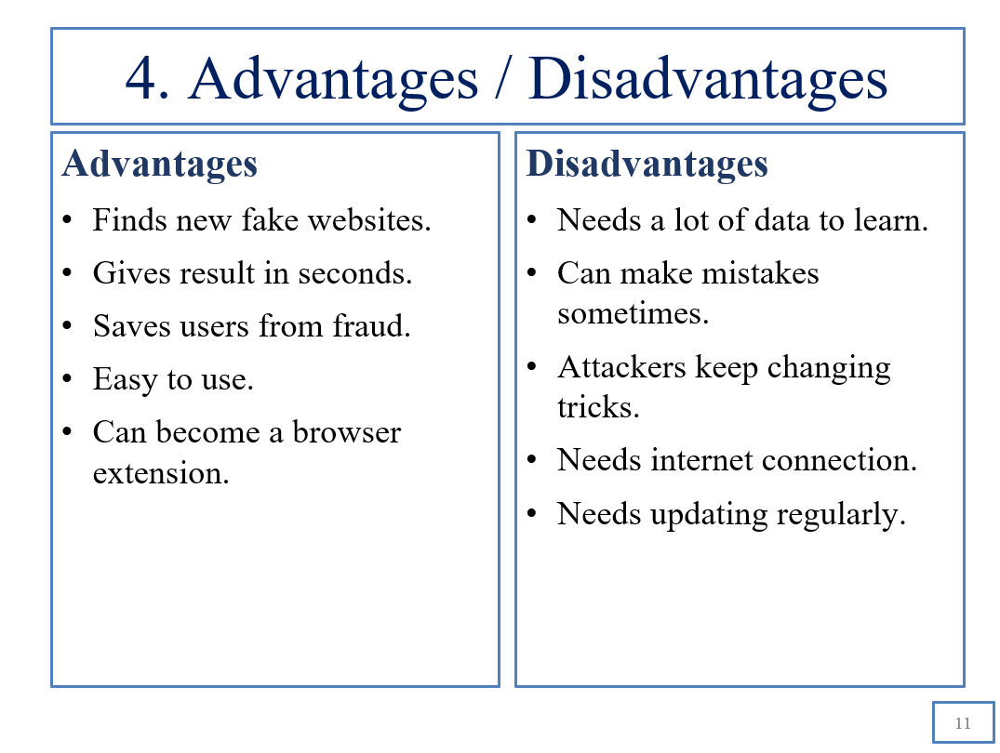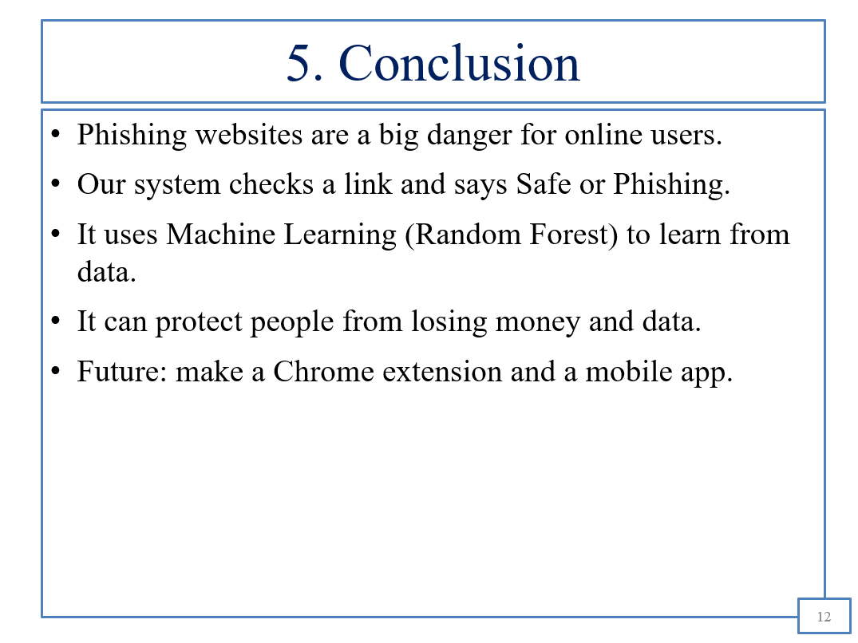
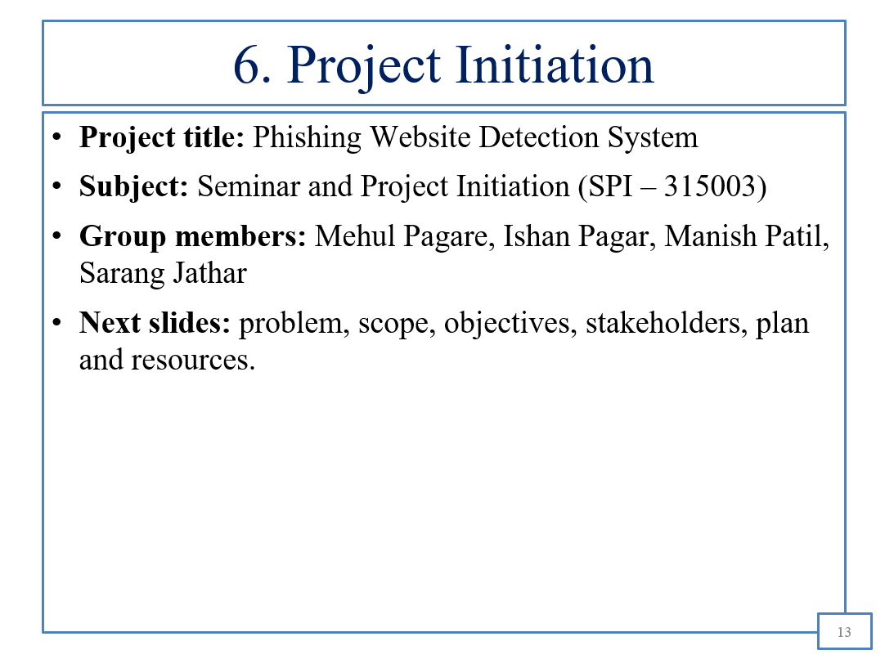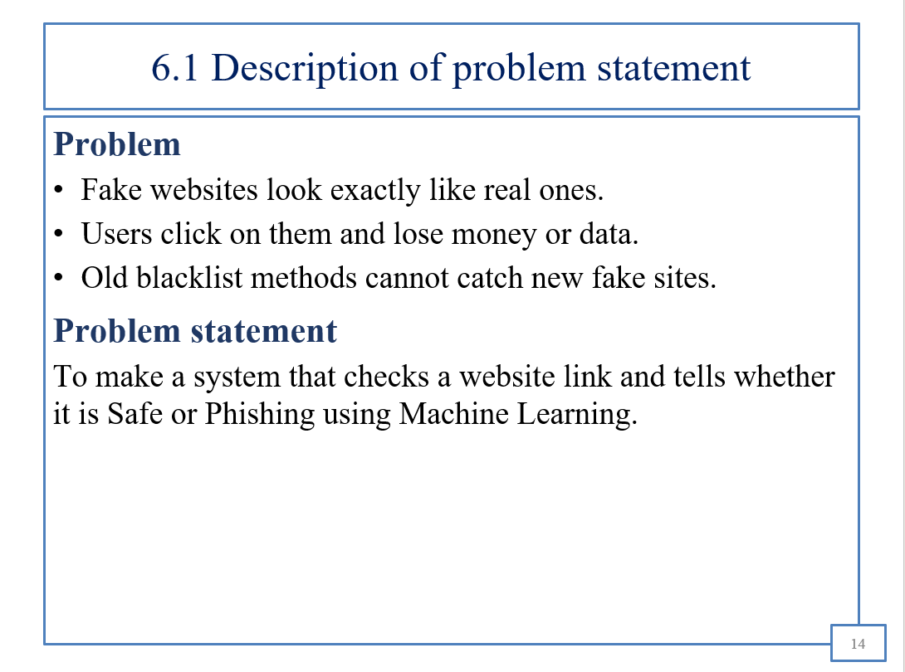
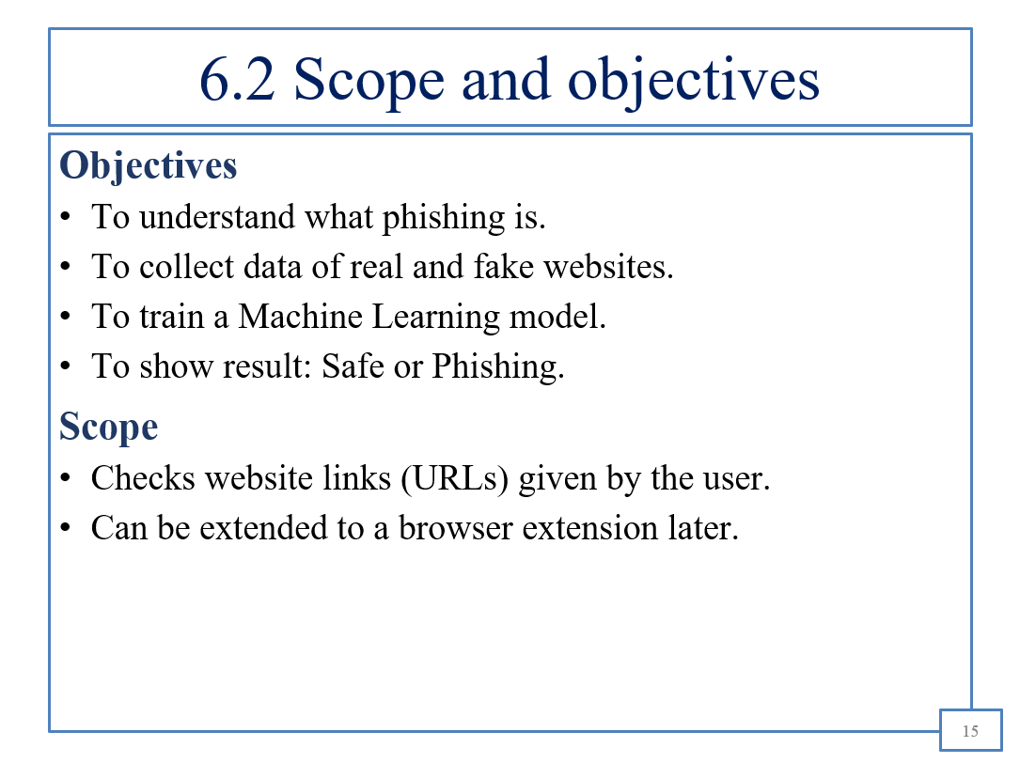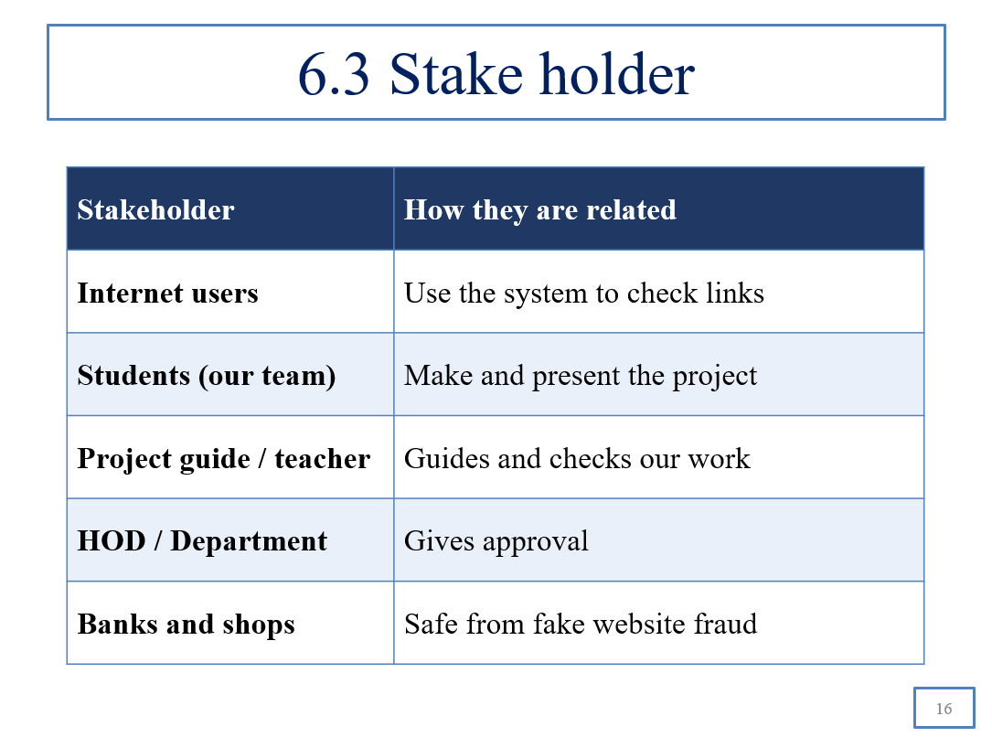
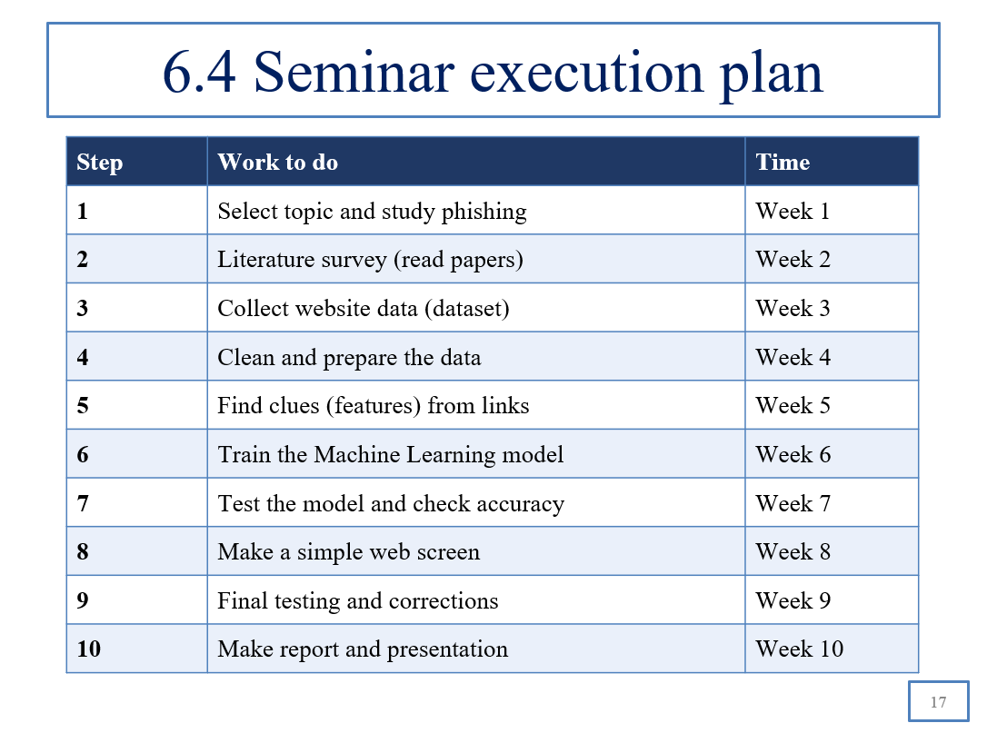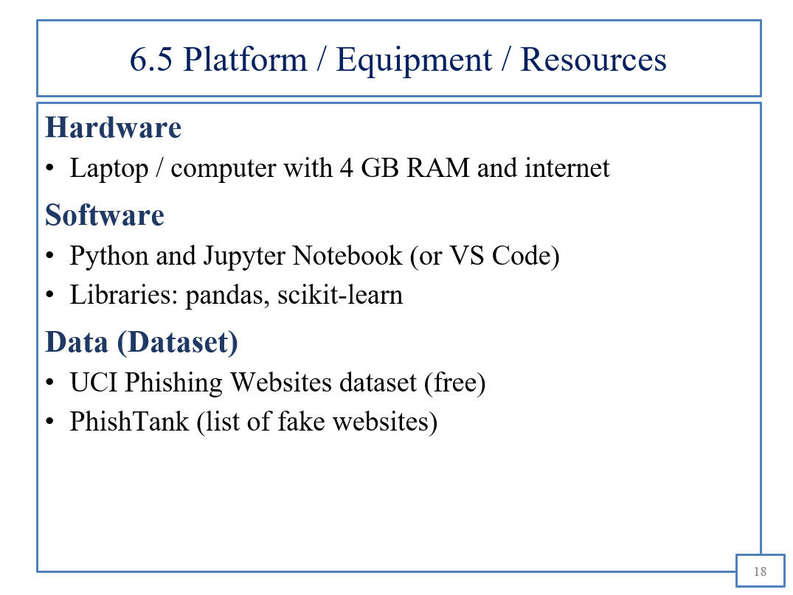
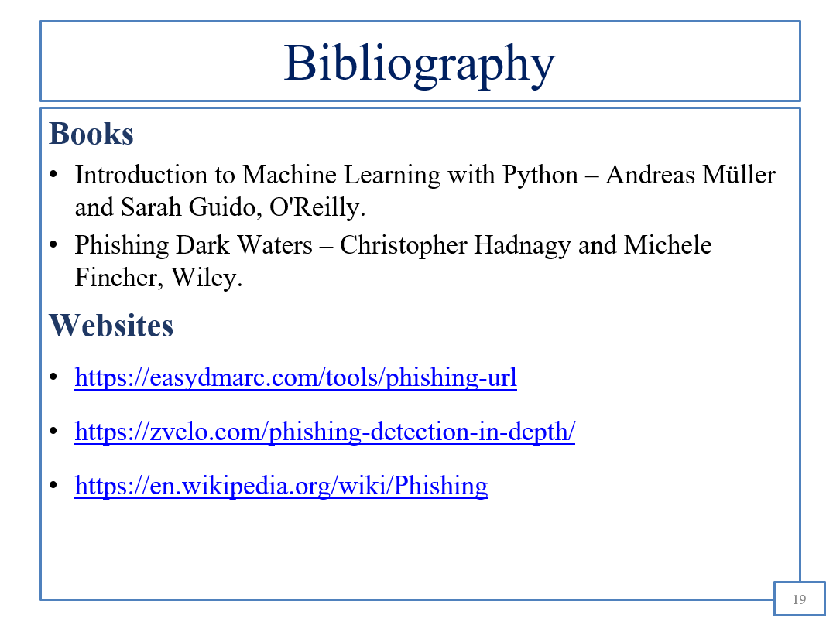
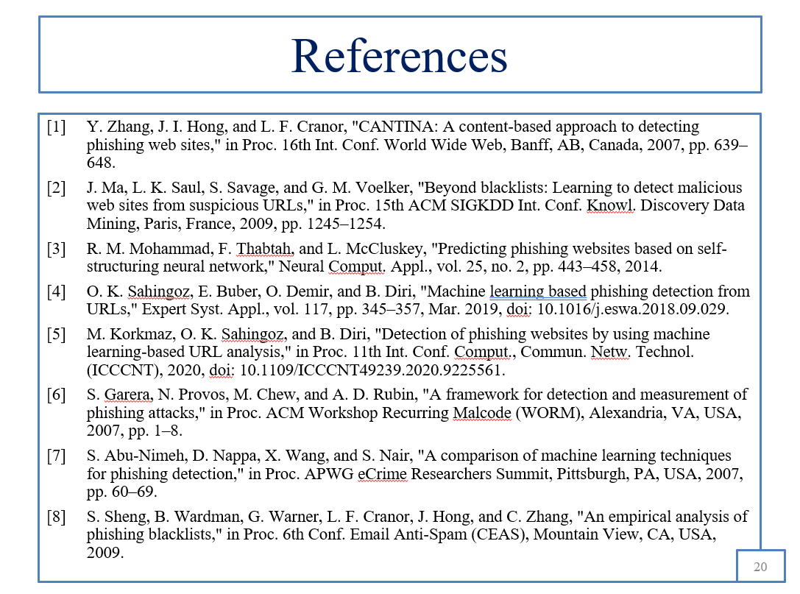
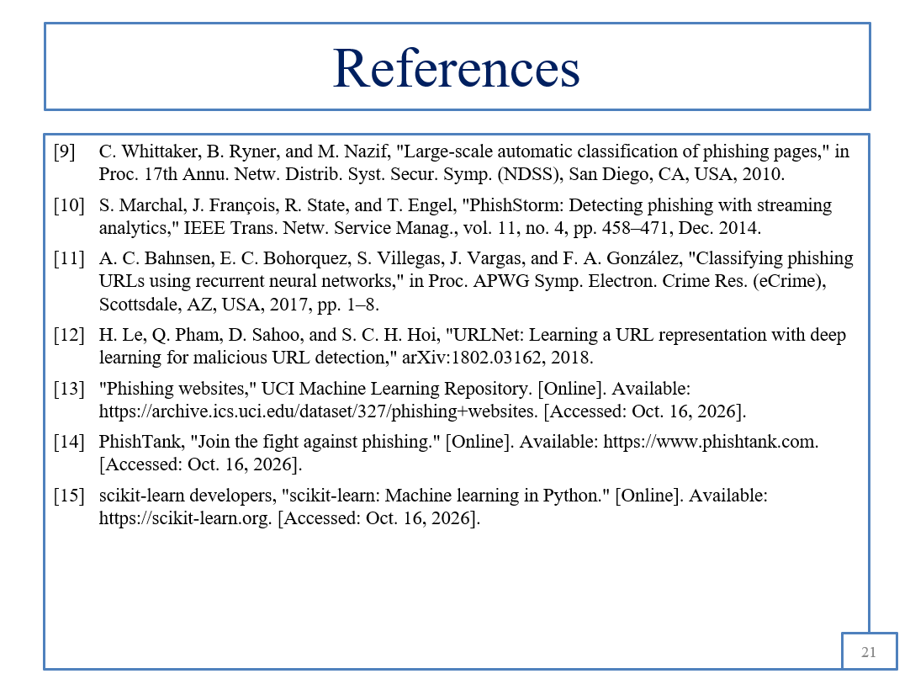

BIBLIOGRAPHY
- Safi, A., and Singh, S. (2023). “A Systematic Literature Review on Phishing Website Detection Techniques.” Journal of King Saud University – Computer and Information Sciences, Volume 35, Issue 2, pp. 590–611. Available at: https://doi.org/10.1016/j.jksuci.2023.01.004
- Tang, L., and Mahmoud, Q. H. (2021). “A Survey of Machine Learning-Based Solutions for Phishing Website Detection.” Machine Learning and Knowledge Extraction, Volume 3, Issue 3, pp. 672–694. Available at: https://doi.org/10.3390/make3030034
- Zieni, R., Massari, L., and Calzarossa, M. C. (2023). “Phishing or Not Phishing? A Survey on the Detection of Phishing Websites.” IEEE Access, Volume 11, pp. 18499–18519. Available at: https://doi.org/10.1109/ACCESS.2023.3247135
- Ma, J., Saul, L. K., Savage, S., and Voelker, G. M. (2009). “Beyond Blacklists: Learning to Detect Malicious Web Sites from Suspicious URLs.” Proceedings of the 15th ACM SIGKDD International Conference on Knowledge Discovery and Data Mining, pp. 1245–1254. Available at: https://doi.org/10.1145/1557019.1557153
- Le, A., Markopoulou, A., and Faloutsos, M. (2011). “PhishDef: URL Names Say It All.” Proceedings of IEEE INFOCOM, pp. 191–195. Available at: https://doi.org/10.1109/INFCOM.2011.5934995
- Reyes-Dorta, N., Caballero-Gil, P., and Rosa-Remedios, C. (2024). “Detection of Malicious URLs Using Machine Learning.” Wireless Networks, Volume 30, pp. 7543–7560. Available at: https://doi.org/10.1007/s11276-024-03700-w
- Mohammad, R., and McCluskey, L. (2012). “Phishing Websites” [Dataset]. UCI Machine Learning Repository. Available at: https://archive.ics.uci.edu/dataset/327/phishing
- Prasad, A., and Chandra, S. (2024). “PhiUSIIL Phishing URL (Website) Dataset.” UCI Machine Learning Repository. Available at: https://archive.ics.uci.edu/dataset/967/phiusil-phishing-url-dataset
- OpenPhish. “Phishing Feeds.” Available at: https://openphish.com/phishing_feeds.html
- Google. “Google Safe Browsing API Documentation.” Available at: https://developers.google.com/safe-browsing/reference/rest
- Python Software Foundation. “Python Documentation.” Available at: https://docs.python.org/3/
- NumPy Developers. “NumPy Documentation.” Available at: https://numpy.org/doc/stable/

REFERENCES
- Safi, A., and Singh, S. (2023). “A Systematic Literature Review on Phishing Website Detection Techniques.” Journal of King Saud University – Computer and Information Sciences, Volume 35, Issue 2, pp. 590–611. Available at: https://doi.org/10.1016/j.jksuci.2023.01.004
- Tang, L., and Mahmoud, Q. H. (2021). “A Survey of Machine Learning-Based Solutions for Phishing Website Detection.” Machine Learning and Knowledge Extraction, Volume 3, Issue 3, pp. 672–694. Available at: https://doi.org/10.3390/make3030034
- Zieni, R., Massari, L., and Calzarossa, M. C. (2023). “Phishing or Not Phishing? A Survey on the Detection of Phishing Websites.” IEEE Access, Volume 11, pp. 18499–18519. Available at: https://doi.org/10.1109/ACCESS.2023.3247135
- Ma, J., Saul, L. K., Savage, S., and Voelker, G. M. (2009). “Beyond Blacklists: Learning to Detect Malicious Web Sites from Suspicious URLs.” Proceedings of the 15th ACM SIGKDD International Conference on Knowledge Discovery and Data Mining, pp. 1245–1254. Available at: https://doi.org/10.1145/1557019.1557153
- Le, A., Markopoulou, A., and Faloutsos, M. (2011). “PhishDef: URL Names Say It All.” Proceedings of IEEE INFOCOM, pp. 191–195. Available at: https://doi.org/10.1109/INFCOM.2011.5934995
- Reyes-Dorta, N., Caballero-Gil, P., and Rosa-Remedios, C. (2024). “Detection of Malicious URLs Using Machine Learning.” Wireless Networks, Volume 30, pp. 7543–7560. Available at: https://doi.org/10.1007/s11276-024-03700-w
- Mohammad, R., and McCluskey, L. (2012). “Phishing Websites” [Dataset]. UCI Machine Learning Repository. Available at: https://archive.ics.uci.edu/dataset/327/phishing
- Prasad, A., and Chandra, S. (2024). “PhiUSIIL Phishing URL (Website) Dataset.” UCI Machine Learning Repository. Available at: https://archive.ics.uci.edu/dataset/967/phiusil-phishing-url-dataset
- OpenPhish. “Phishing Feeds.” Available at: https://openphish.com/phishing_feeds.html
- Google. “Google Safe Browsing API Documentation.” Available at: https://developers.google.com/safe-browsing/reference/rest

SEMINAR and PROJECT INITIATION Assessment / Evaluation
Sr.  No | Enrollment  Number | Seat Number | Name of student
1 | 24610960226 | 388534 | Pagar Ishan Pagar
2 | 24610960227 | 388535 | Pagare Mehul Sandip
3 | 24610960203 | 388516 | Jathar Sarang Arvind
4 | 24610960220 | 388528 | Patil Manish Chandrakant
Formative Assessment
Sr. No. | Criteria | Weightage | Exam Seat number
Sr. No. | Criteria | Weightage | 388534 | 388535 | 388516 | 388528
1 | Selection Topic / Theme of seminar | 5
2 | Literature review and data presentation | 5
3 | Quality of Preparation and innovativeness | 5
4 | Q-A handling | 5
5 | Time Management | 5
6 | Seminar Presentation report | 10
7 | Selection of Theme of Problem Statement and its innovativeness | 5
8 | Stages of development of Action plan | 5
9 | Prototyping | 5
 | Total | 50
 | Scaled to 25

Sign :
Name : Shraddha S Hajari
(Course Expert/s)

